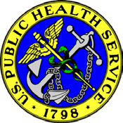
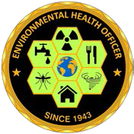
United States Public Health Service
Environmental Health Officer Professional Advisory Committee

Training Event

What: ER310: Food Safety Issues in the event of Disasters
When: Sunday, July 12th (0800– 1700) & Monday, July 13th (0800– 1200)
Target Audience: EHOs with minimal experience responding to food safety disaster events
Cost: Free, Pre-Registration Required
Registration forms will be sent to the first 10 EHOs who confirm their attendance for the course.
Please contact CDR Robert Gibbs (Robert.Gibbs@foh.hhs.gov) to confirm

FDA and NEHA will be offering ER310 at NEHA’s AEC pre-conference in NYC. This course incorporates interactive and performance based activities to address food safety issues in the event of a disaster. Food safety response and recovery topics that will be covered include situational assessments, inspectional concerns, salvage, and other mitigation strategies related to retail food and processing facilities. The course is targeted towards state, local, tribal and territorial regulators, environmental health specialists as well as food safety inspection officers who respond to local disasters.

Course prerequisites:
- ER310W100 Food Safety Issues in the Event of Disasters: An Introduction web course
- Food Code (FD112 classroom or online (FDAFC01-FDAFC11) through ComplianceWire).
Link to the prerequisites: https://orauportal.fda.gov/stc/ORA/psciis.dll?linkid=720650&mainmenu=ORA&top_frame=1

Please contact CDR Robert Gibbs (Robert.Gibbs@foh.hhs.gov) with questions

